Nathan Heckman

Parallel Programming Task Report

**Question 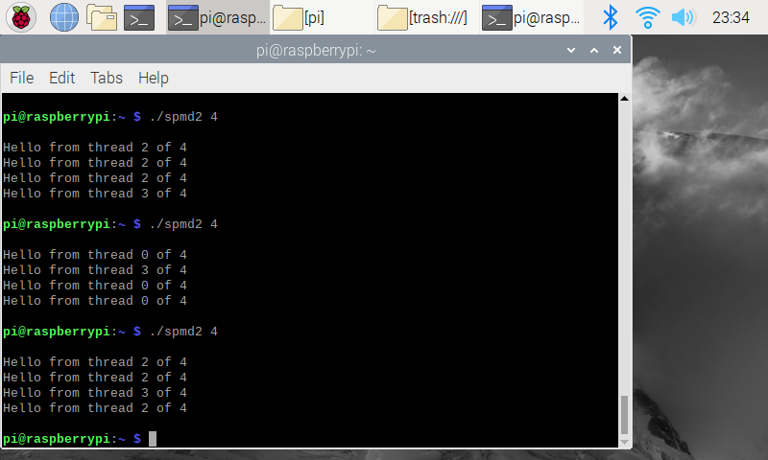2.3 Faulty Code**

This is the output of the spmd2.c program, with the number 4 as the variable number of threads. The threads are not properly displayed or used since each thread did not have its own copy of the id and numThreads variables.

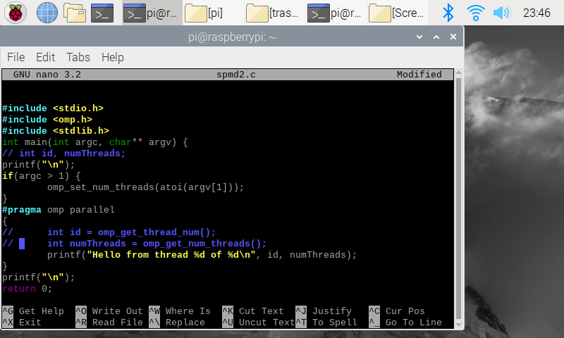**Question 2.4.1 Fixed Code**

Changed code is highlighted in blue as a comment. After I took this screenshot I uncommented the two integer assignments inside #pragma so each thread would have its own unique copy of the variable and could therefore could properly update the values with its own assigned thread number.

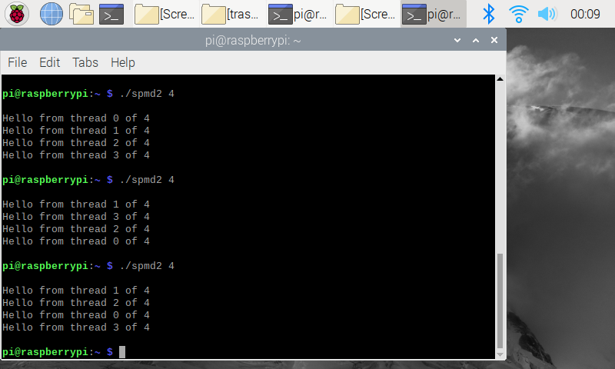

**Question 2.4.1 Fixed Code Output**

The new code produces the desired output of a unique thread number for each new line. No matter what order the threads finish, each is included in exactly one line of output.